Additional information on the dataset groups and datasets in the ModE-Sim experiment

General information
The ModE project at WDC contains 3 components, each provided as a separate experiment (Figure 1). This additional information provides a description of the dataset groups and datasets in the Mode-Sim experiment. In another additional info file you will find example run scripts that document the experimental setup of ModE-Sim. For the related reanalysis products ModE-RA and ModE-RAclim info files equivalent to this one can be found linked at their experiment page.

Dataset groups in ModE-Sim
The experiment ModE-Sim contains 5 dataset groups that refer to subsets of the ModE-Sim ensemble that use slightly different forcings and/or cover different epochs. An overview is provided in Figure 2, for details on the experimental setup please refer to the documentation paper on Mode-Sim, which is linked in the experiment description.

Datasets within the dataset groups
Each of the dataset group contains the following Datasets:

members (abs) - contains absolute values for all individual ensemble members of the according ModE-Sim set. Files are provided as NetCDF files, with one variable from one ensemble member per file for the whole period. Filenames are structured as in the following example:

ModE-Sim_set_1420-1_m001_geopoth_50000_abs_1420-1849_mon.nc, where
- ModE-Sim is the experiment name
- set_1420-1 is the set identifier
- m001 is the member number
- geopoth_50000 is the variable name (geopoth) including, for 3D variables, the level (here: 500 hPa). A list of the variables can be found below.
- abs is for absolute values (at the moment same for all ModE-Sim data)
- 1420-1849 is the period covered
- mon indicates that the data are provided as monthly means

ensemble statistics (abs) - contains ensemble means, ensemble standard deviations, and ensemble minima/maxima for the according ModE-Sim set. Files are provided as NetCDF files, with each file containing one statistical property computed across the according set for one variable for the whole period. Filenames are structured as in the following example:

ModE-Sim_set_1420-1_ensstd_geopoth_50000_abs_1420-1849_mon.nc, where
- ModE-Sim is the experiment name
- set_1420-1 is the set identifier
- ensstd is the statistical property provided for the set (here: ensemble standard deviation).
- geopoth_50000 is the variable name (geopoth) including, for 3D variables, the level (here: 500 hPa). A list of the variables can be found below.
- abs is for absolute values (at the moment same for all ModE-Sim data)
- 1420-1849 is the period covered
- mon indicates that the data are provided as monthly means

forcings - includes volcanic forcings and ocean boundary conditions (SST and sea ice) for those sets that do not use standard PMIP4/HadISST forcings/boundary conditions. The naming of the forcing files and boundary conditions were adjusted to fit the naming of the ensemble members to indicate which forcings belong to which members.

List of variables in ModE-Sim
The following variables are included in ModE-Sim:

slp mean sea level pressure [Pa]
temp2 2m air temperature [K]
totprec total precipitation [kg m-2 s-1]
geopoth_50000 500 hPa geopotential height [m]
omega_50000 500 hPa vertical velocity [Pa s-1]
u_85000 850 hPa u-wind [m s-1]
v_85000 850 hPa v-wind [m s-1]

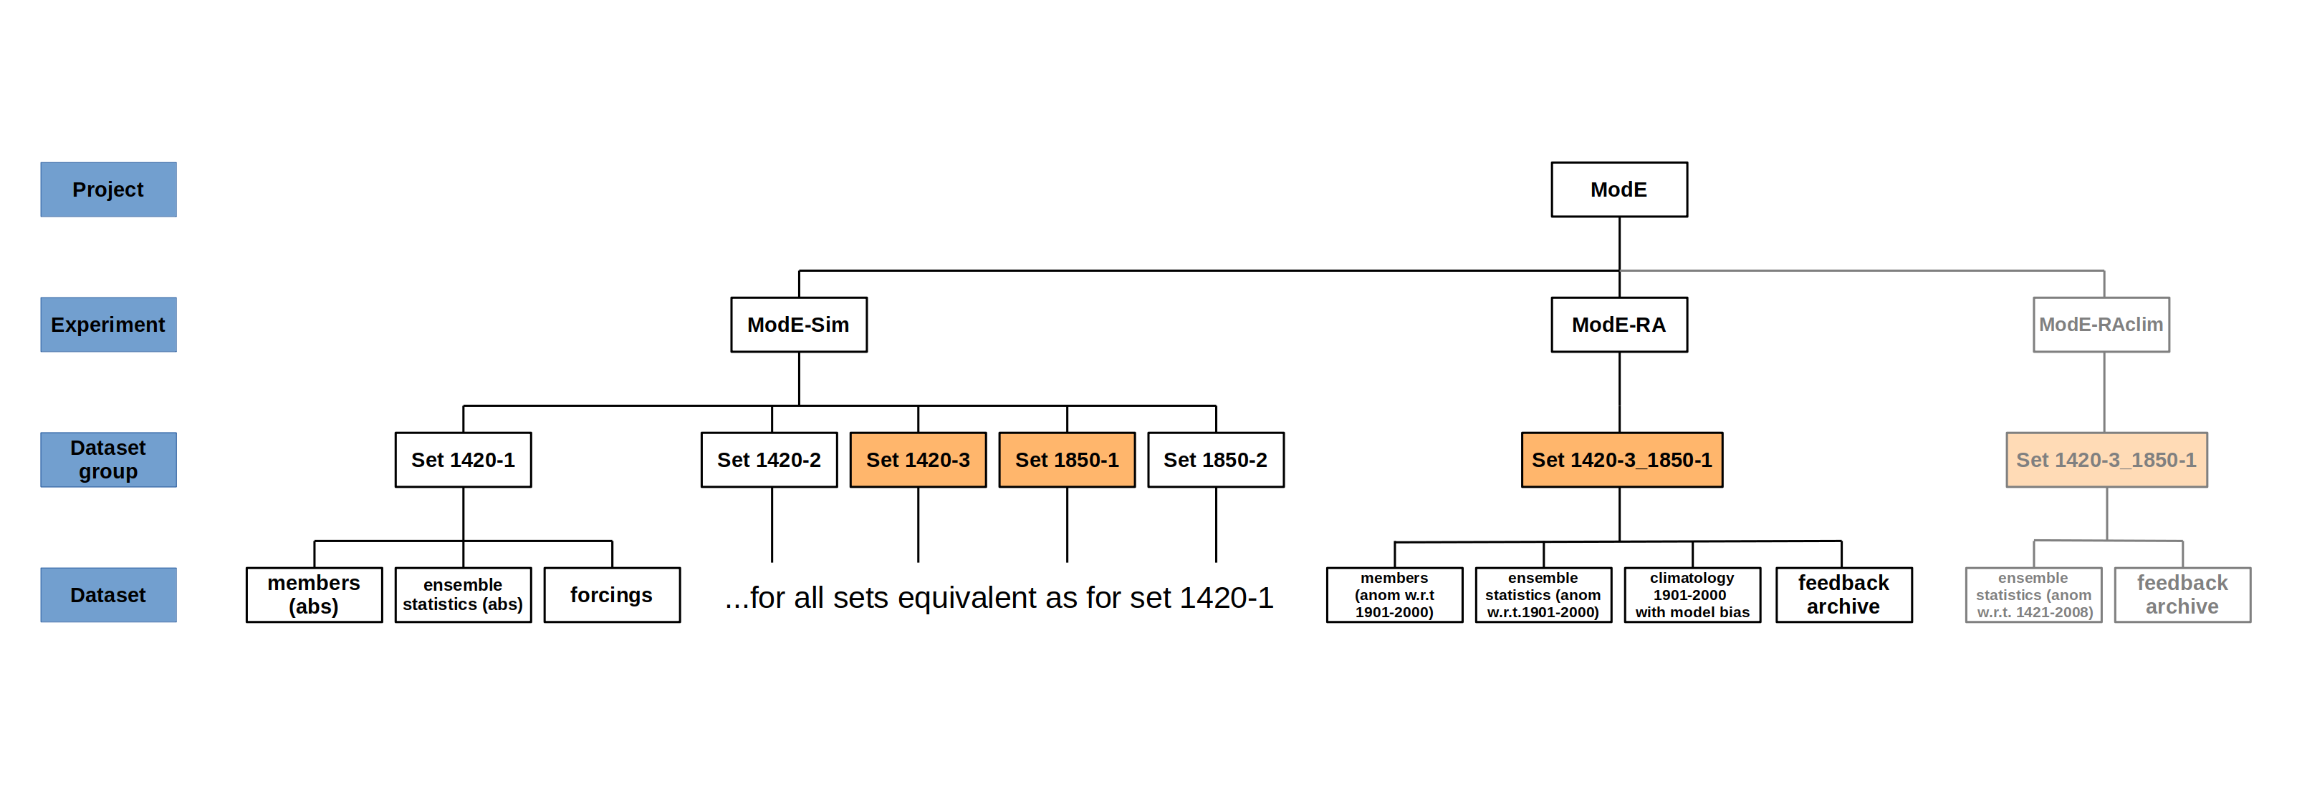Figure 1: Overview of the structure of the ModE project at WDC. The ModE-Sim sets highlighted in orange are those which where used as a-priori state for the reanalysis product provided as separate experiments «ModE-RA»/»ModE-Raclim» within this project.
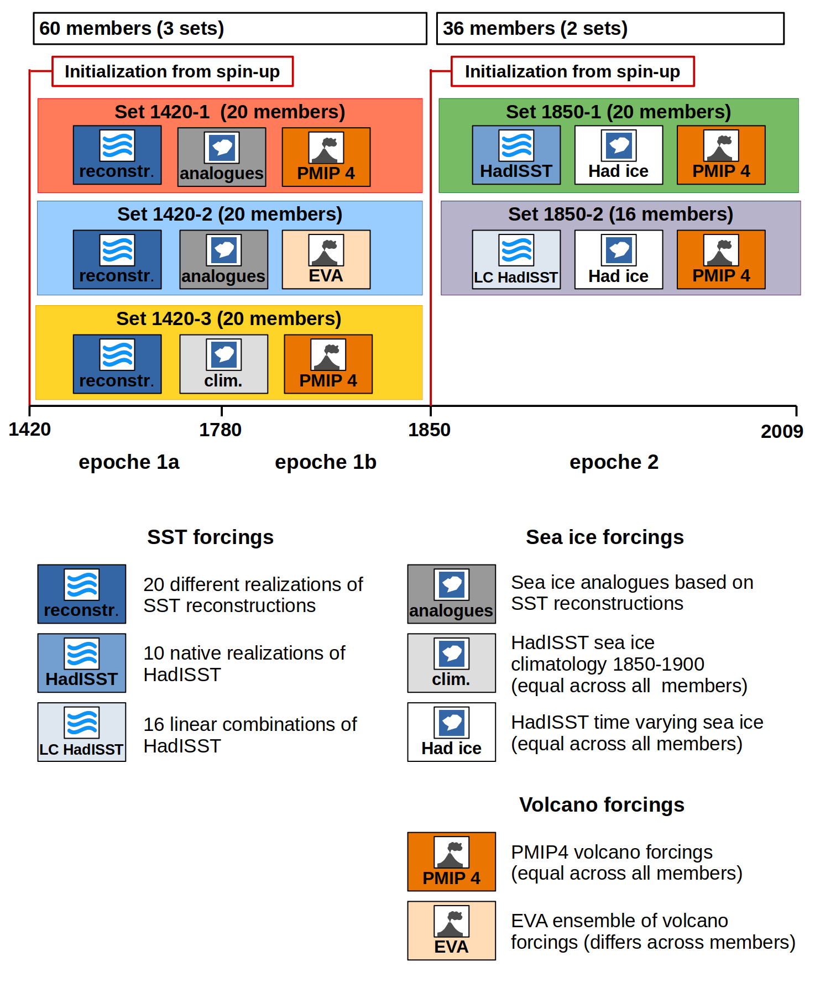Figure 2: Overview on the setup of the experiment sets in ModE-Sim and their forcings (figure from Hand et al., 2023).

